4) Perform basic Image Handling and processing operations on
the image
AIM:- Read an image in python and Dilate an Image using Dilate function.
PROGRAM
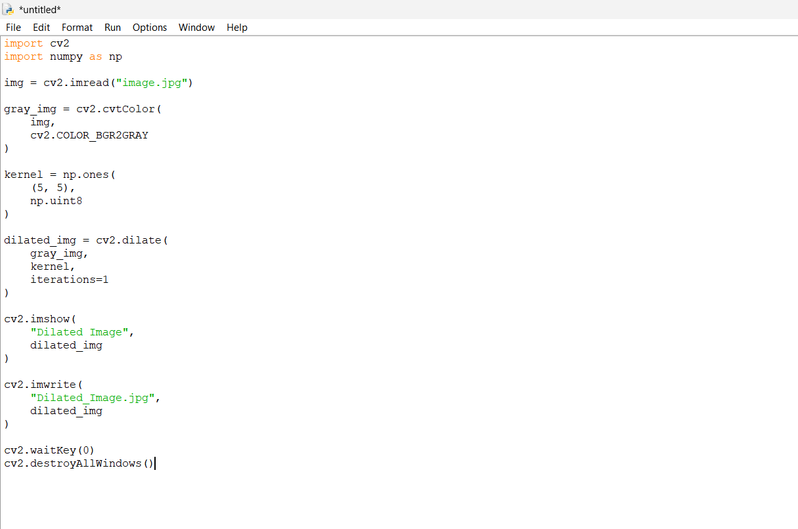

OUTPUT


